Step 1: Data Collection
This step involves importing libraries and loading the dataset into a pandas DataFrame. It helps inspect the dataset structure, preview data samples, and verify that it loads correctly for analysis.
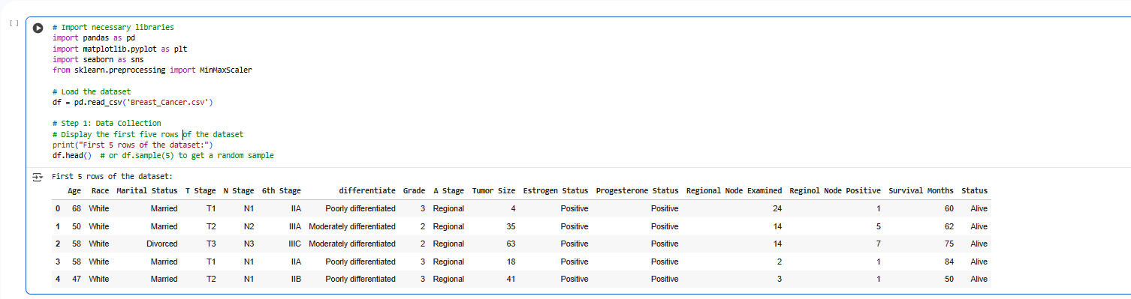 Scatter Plot: Age vs Tumor Size
The scatter plot visualizes the relationship between a patient’s age and tumor size. It helps determine whether tumor size tends to increase with age or shows random variation across different age groups.
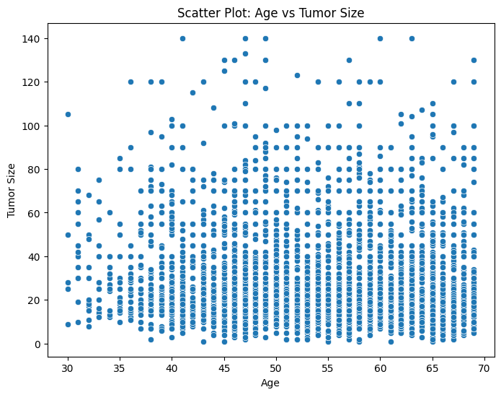
Bar Chart: Marital Status Distribution
This bar chart displays the frequency of different marital statuses among patients. It reveals demographic distribution, showing whether certain marital groups are more represented in the dataset or linked to specific outcomes.
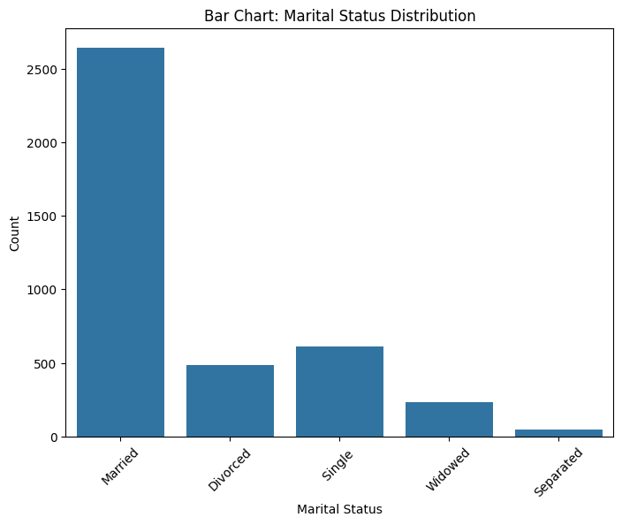
Histogram: Tumor Size Distribution
The histogram shows how tumor sizes are distributed within the dataset. It helps identify skewness, central tendency, and variation in tumor sizes across patients, providing insights into the overall dataset shape.
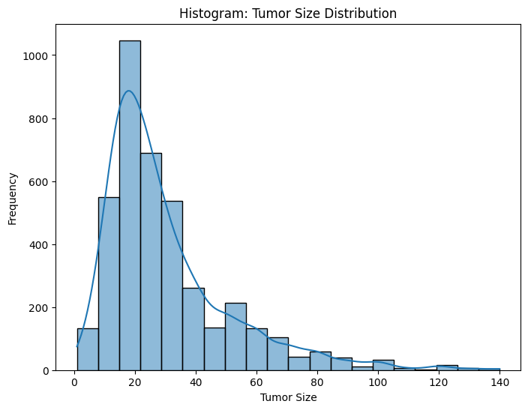
Box Plot: Tumor Size by Estrogen Status
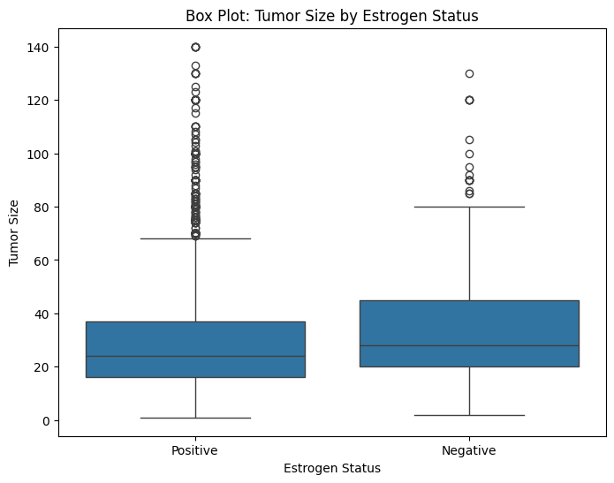
This box plot compares tumor size distributions based on estrogen status. It helps detect differences in tumor growth patterns among patients with positive or negative estrogen receptors, and spot potential outliers.
Handling Missing Values
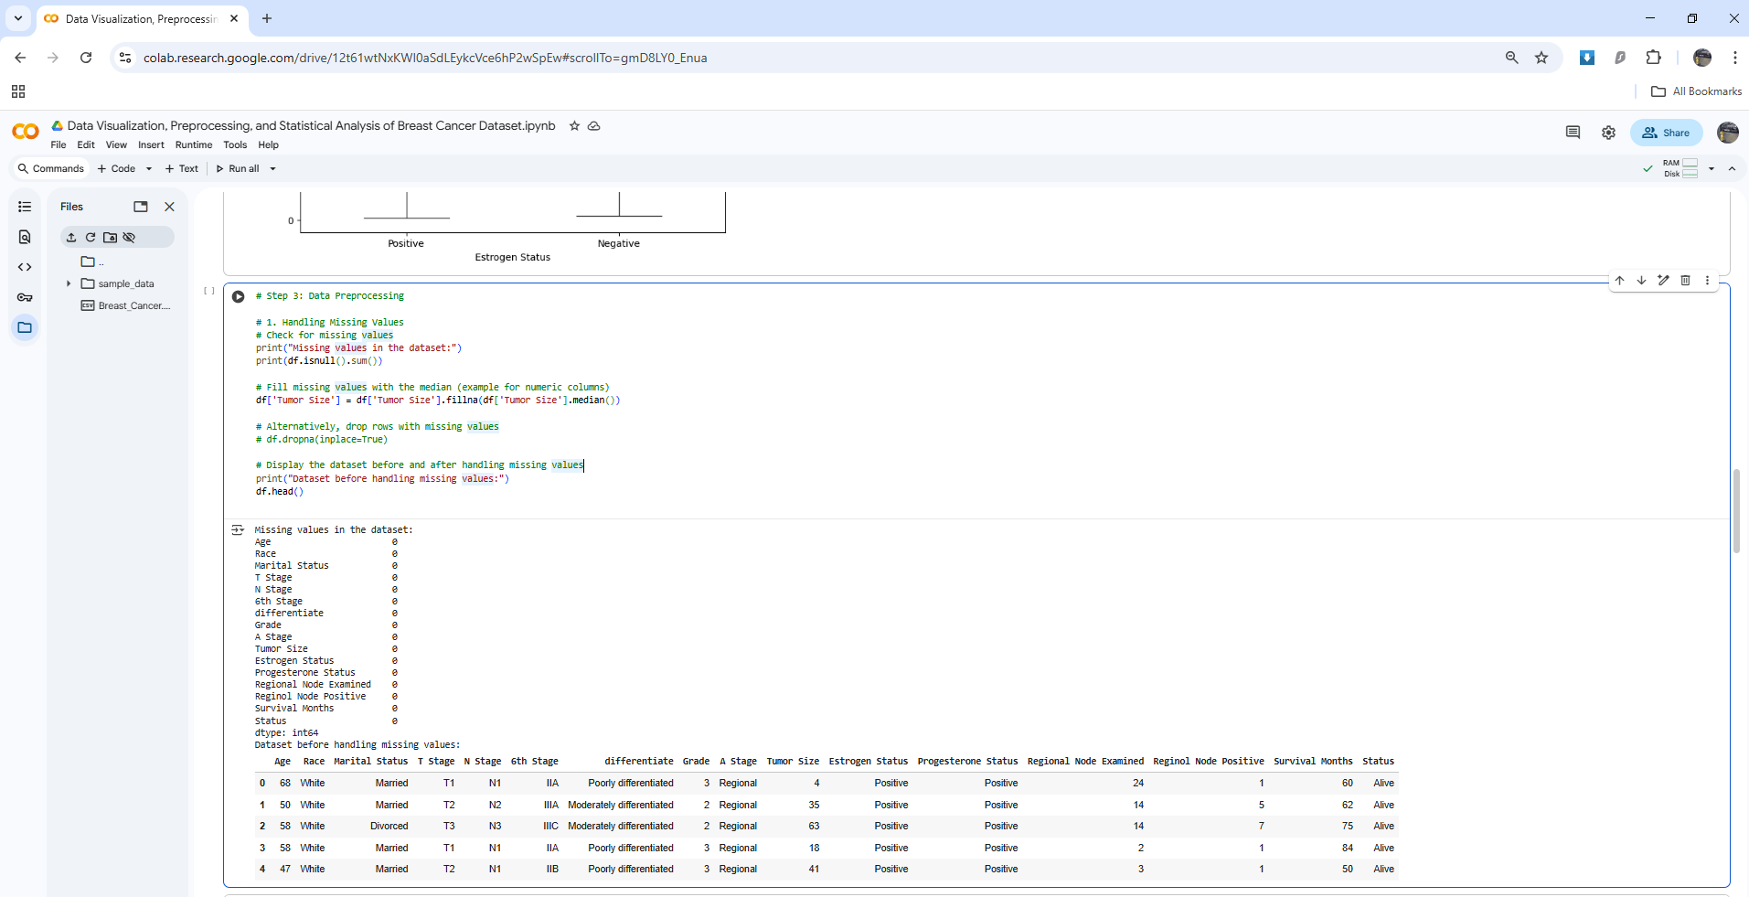
This step checks for and handles missing data using imputation or deletion methods. Ensuring no missing values is essential for maintaining data integrity and preventing errors in subsequent analyses.
Outlier Detection and Removal (IQR Method)
This step identifies and removes outliers using the interquartile range (IQR) technique. Removing extreme values enhances data reliability and prevents them from distorting model performance or statistical summaries.
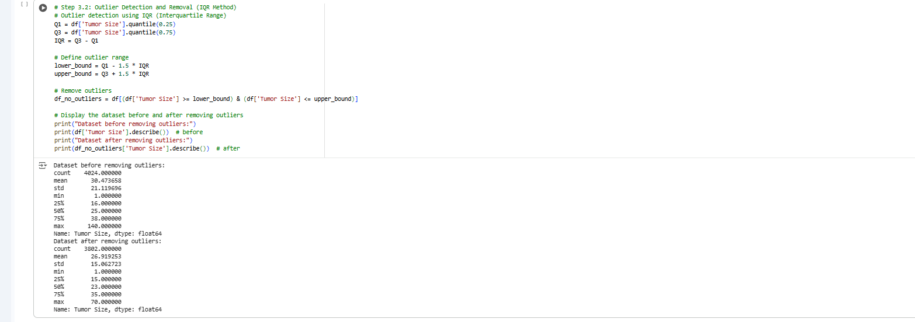
Data Reduction (Dropping Irrelevant Columns)
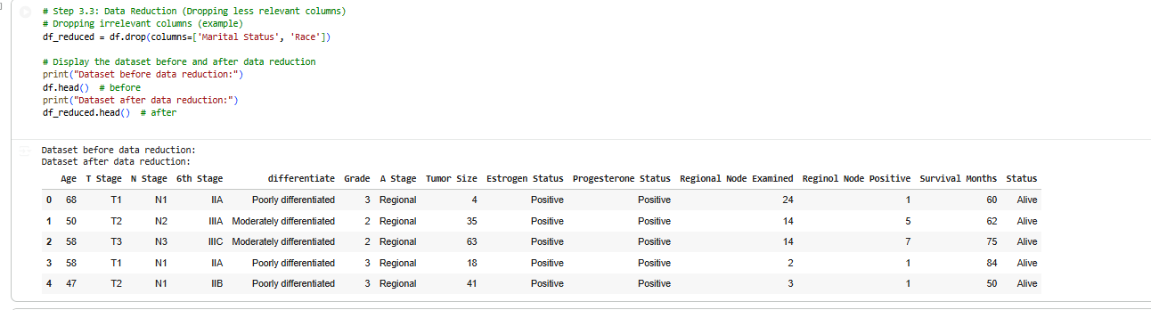
Less relevant or redundant columns like ‘Marital Status’ or ‘Race’ are removed to simplify the dataset. This helps focus analysis on attributes more directly related to tumor characteristics and outcomes.
Data Scaling (Min-Max Normalization)
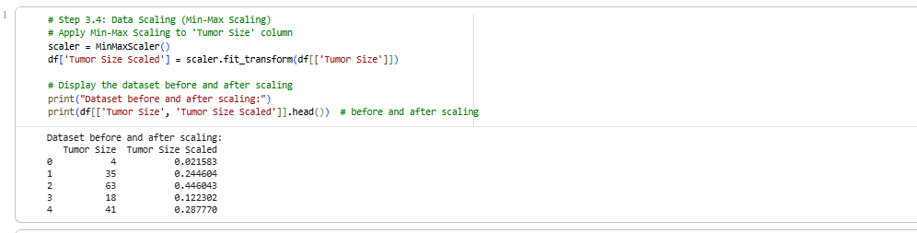
Min-Max Scaling transforms the ‘Tumor Size’ feature to a standardized range (0–1). This normalization ensures consistent scale across features, preventing large numerical differences from biasing the analysis or models.
Statistical Summary
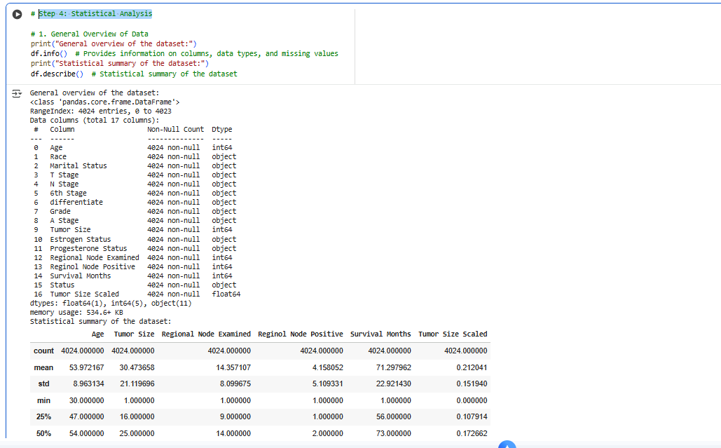
The dataset’s structure, data types, and statistical measures are reviewed using df.info() and df.describe(). This overview highlights numerical trends, categorical diversity, and overall data quality before modeling.

Central Tendency and Dispersion Analysis
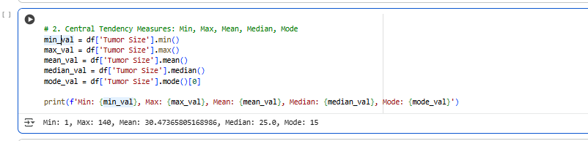
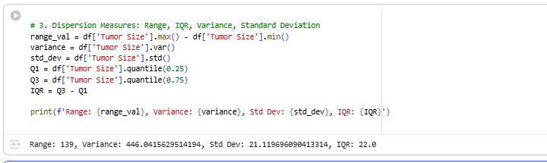
Calculating mean, median, mode, range, variance, and standard deviation quantifies data spread and consistency. These measures summarize tumor characteristics and help identify whether the dataset follows a normal distribution.
Correlation Matrix
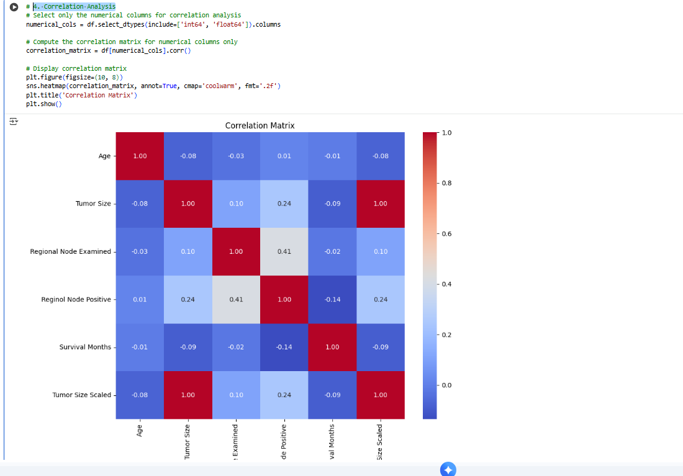
The heatmap visualizes relationships between numerical variables. Correlation analysis reveals how strongly variables like age, tumor size, and survival months are interrelated, helping guide feature selection for predictive modeling.

